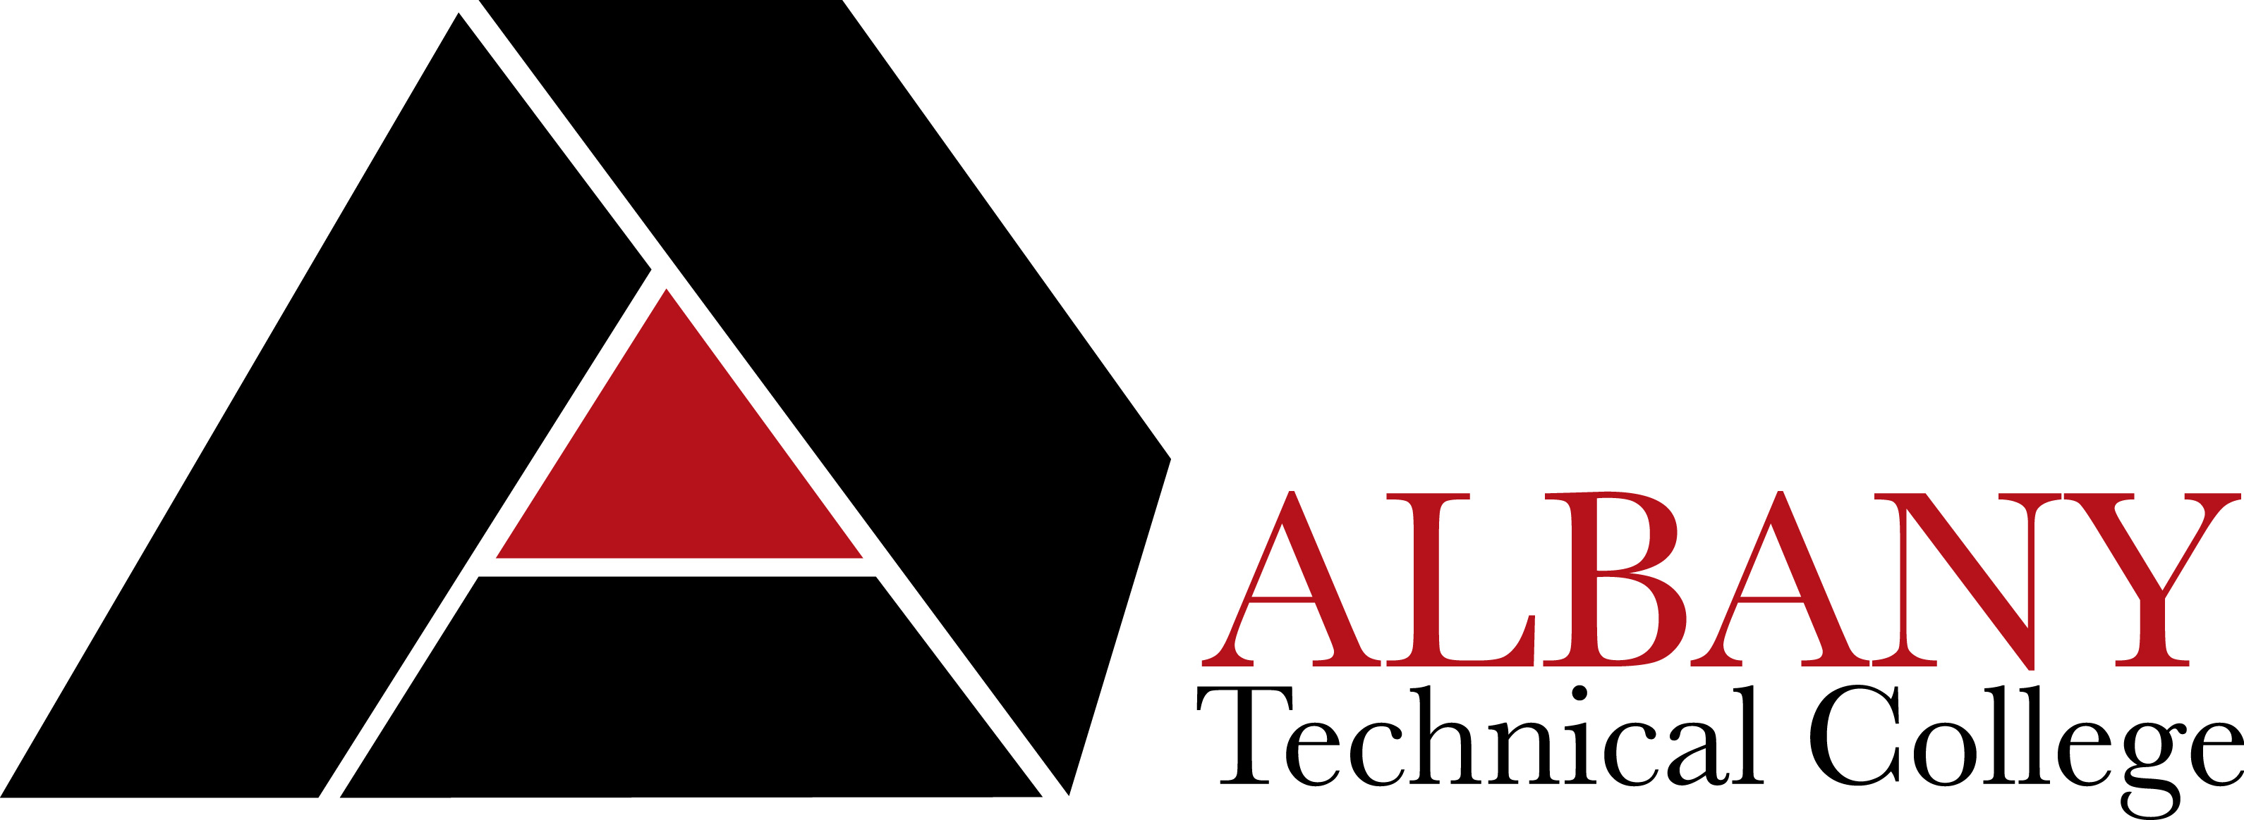
Library Media Center Interlibrary Loan
Periodical Request Form

Only faculty, staff, or currently enrolled students may request articles, reports, or newsletters through the Inter-Library Loan program. Students will be asked to verify enrollment to participate in this service. Please fill out one form per book.

Directions: Save this form. Click in each box and type the requested information. Please provide as much information as possible. You may be contacted for additional information if needed. E-mail the completed form as directed below.

Borrower Information
(You will be contacted using the information below. An incomplete or illegible form may delay processing.)

Borrower’s name:
Date:
Check one: Faculty Staff Student
Department/Program:
Mailing Address (street, city, state, zip):
Phone:
Email:

Periodical Citation
Please enter as much information as possible.

Periodical Title:
Title of the Article, Report or Newsletter:
Page number of the article (if known):

Receiving Requested Periodicals

The library staff will check our own collection before submitting orders for requested articles, reports, etc. Some lending institutions, due to the database license restrictions or loan policies may not be able to supply requested books. Requested books will be shipped to the library requesting the item. Delivery may take up to 2 weeks. Borrower will be notified to pick up books upon arrival. Borrower will be notified immediately via phone or email if requested books are not available.

Generally, there is not a charge for the Interlibrary Loan requests. However, if charges are incurred, they are the responsibility of the requestor. Designate the maximum amount you are willing to pay if charges are incurred (postage, fee from loaning library, etc.):
$ ___________. If cost exceeds the maximum amount, the article will not be ordered.

Please note the copyright restriction below if you are requesting a photocopy or reproduction.

Warning: copyright restrictions may apply. The copyright law of the United States (Title 17, US Code) governs the making of photocopies or other reproductions of copyrighted material. Libraries and archives are only authorized to furnish a photocopy or reproduction under certain specifications. One of these specifications is that the photocopy or reproduction is not to be used for any purpose other than for private research, study, or scholarship. If a user makes a request for any other purpose, that user will be liable for copyright infringement. This institution reserves the right to refuse an order if, in its judgment, fulfillment of the order will involve copyright infringement.

E-mail the completed form as an attachment to rcalhoun@albanytech.edu, or you may deliver your request to the Library Media Center at the Dougherty County Campus, Building B, 1704 S. Slappey Blvd., Albany GA 31701.

This section to be completed by Library Media Center Staff

Form accepted by:

Date:

Comments:

